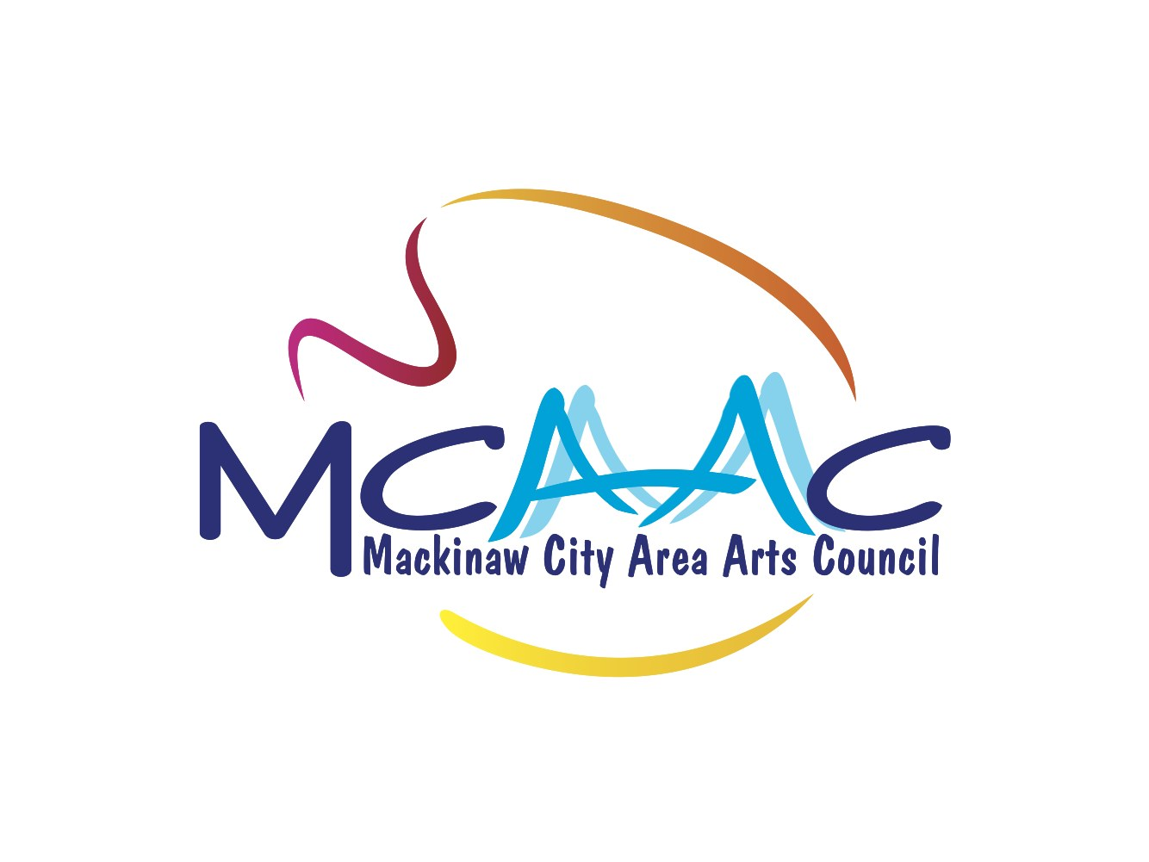 Fall, 2025

Mackinaw City Area Arts Council
Arts Trade School/College Scholarship

Information and Application

The Mackinaw City Area Arts Council will award a $500.00 scholarship to a graduating senior from the Mackinaw City Public School who will be attending an accredited college or trade school and will be pursuing a degree in an arts related field of study. This study might include visual arts, performing arts, literary arts, applied arts, culinary arts, and industrial arts.

The scholarship will be awarded at the discretion of the Mackinaw City Area Arts Council Board of Directors.

The scholarship will be announced at the high school graduation ceremony and will be awarded at the completion of the first semester/term of post-secondary education.
In order to receive the scholarship award, the recipient must be a full-time student and have established at least a 2.5 grade point average for their first term/semester. The scholarship is for the current school year.

Criteria for selection
- Graduating senior of Mackinaw City High School
- Acceptance by an accredited institution of higher learning
- Proven participation and competency in an arts related field
- Completion of application form with recommendations

Complete the following application materials and submit to Mrs. Strittmatter by the last Friday in the month of April.

- Completed application on following page

- One page typed or computer written essay about your goals and career aspirations in the arts and how you plan to achieve this

- Two letters of recommendation from teachers or community members who can vouch for your arts background and talents and/or your qualifications and character

*all of the items above must be included to be considered for scholarship

Application for Mackinaw City Area Arts Council Arts Scholarship

Name ______________________________________ Phone ______________

Address _________________________________________________________

Parent’s name ____________________________________________________

High School GPA ___________ Date of Graduation _____________________

Art field you will pursue ____________________________________________

School you will be attending _________________________________________

Have you been accepted? ______________

Please list your arts studies, projects, experience, etc.
____________________________________________________________

____________________________________________________________

____________________________________________________________

Please list other school activities _____________________________________

____________________________________________________________

____________________________________________________________

Please list community involvement ____________________________________

____________________________________________________________

____________________________________________________________

Please list any work experience ______________________________________

___________________________________________________________

Please list any award, honors or accomplishments ________________________

___________________________________________________________

___________________________________________________________

Any questions, please call/text MaryAnn Moore 734-934-0170

